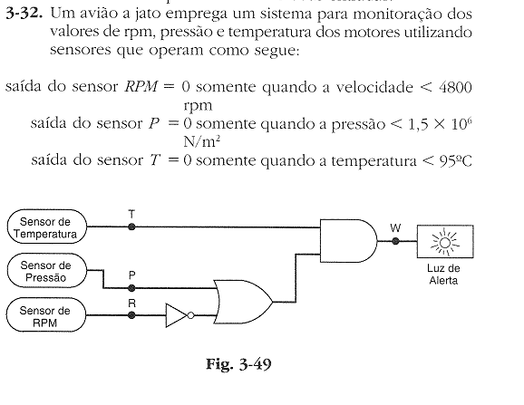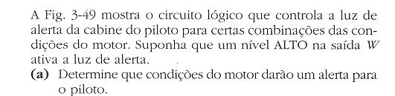

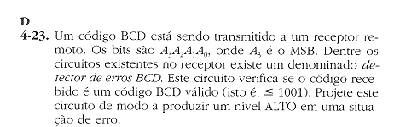

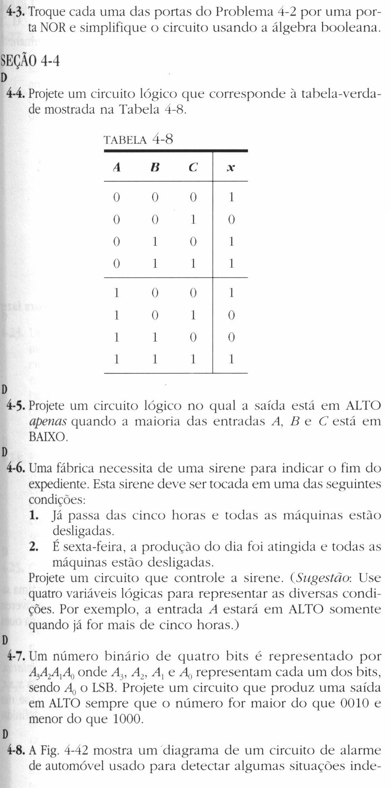

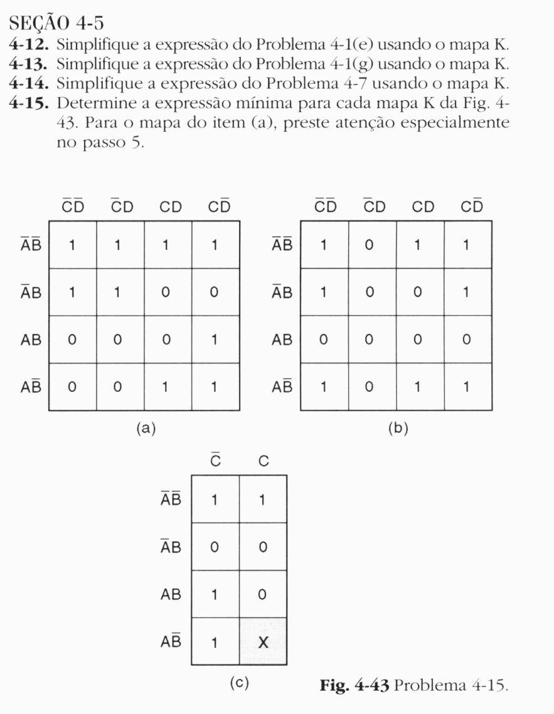





Respostas:

3.32

|  |  |  |  |
| --- | --- | --- | --- |
| T | P | R | W |
| 0 | 0 | 0 | 0 |
| 0 | 0 | 1 | 0 |
| 0 | 1 | 0 | 0 |
| 0 | 1 | 1 | 0 |
| 1 | 0 | 0 | 1 |
| 1 | 0 | 1 | 0 |
| 1 | 1 | 0 | 1 |
| 1 | 1 | 1 | 1 |

4.23

E= A3A2+A3A1

|  |  |  |  |  |
| --- | --- | --- | --- | --- |
| A3 | A2 | A1 | A0 | E |
| 0 | 0 | 0 | 0 | 0 |
| 0 | 0 | 0 | 1 | 0 |
| 0 | 0 | 1 | 0 | 0 |
| 0 | 0 | 1 | 1 | 0 |
| 0 | 1 | 0 | 0 | 0 |
| 0 | 1 | 0 | 1 | 0 |
| 0 | 1 | 1 | 0 | 0 |
| 0 | 1 | 1 | 1 | 0 |
| 1 | 0 | 0 | 0 | 0 |
| 1 | 0 | 0 | 1 | 0 |
| 1 | 0 | 1 | 0 | 1 |
| 1 | 0 | 1 | 1 | 1 |
| 1 | 1 | 0 | 0 | 1 |
| 1 | 1 | 0 | 1 | 1 |
| 1 | 1 | 1 | 0 | 1 |
| 1 | 1 | 1 | 1 | 1 |

4.4

$$x=\overline{B}\overline{C}+BC+\overline{A}B$$

4.5

$$x=\overline{A}\overline{B}+\overline{A}\overline{C}+\overline{B}\overline{C}$$

4.6

$$x=\overline{A}\overline{B}CD+A\overline{B}$$

4.7

$$x=\overline{A3} (A2+A1A0)$$

4.14

a ) $x=\overline{A}\overline{C}+\overline{B}C+AC\overline{D}$

b ) $x=\overline{A}\overline{D}+\overline{B}C+\overline{B}\overline{D}$

c ) $x=A\overline{C}+\overline{B}$

4)

$$f1=\overline{A}\overline{C}+\overline{B}C$$

$$f2=A+B\overline{C}$$

$$f3=AB+A\overline{C}\overline{D}$$